

**JFK (JOY FOR KIDS) UNIVERSAL FOUNDATION DONATION AND SHOPPING CART SYSTEM**

USER MANUAL – FRONT END

MEMBERS:

LOIS ANNE G. LOGRONIO

KATHARYN ALEXANDRE D. MAYO

RENON ERROL C. DADULLA

IT-111

TABLE OF CONTENTS

1. **HOME PAGE**

1.1 Home Page

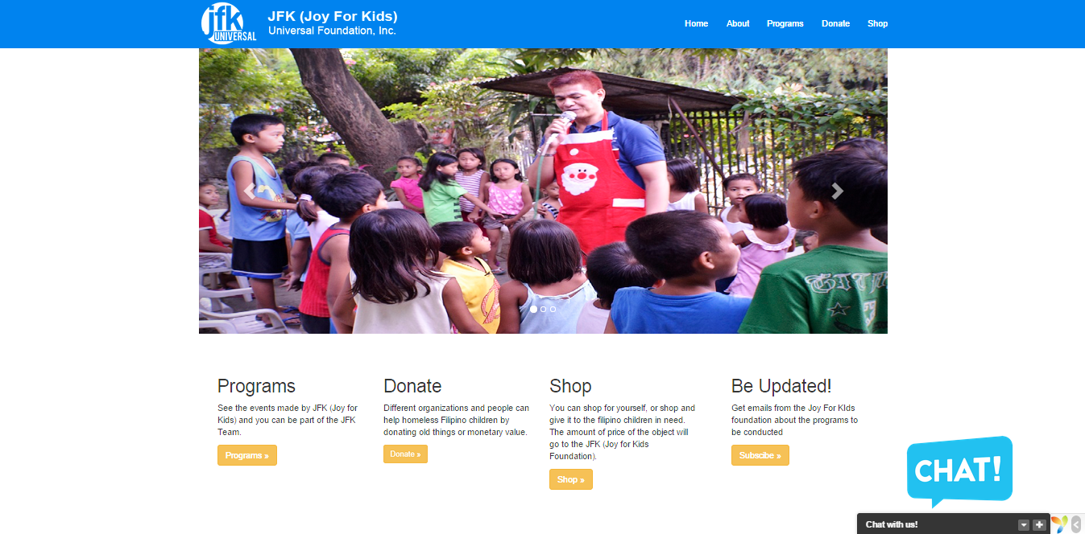

* In this screen shot, it shows all the things that can be done in the website, and it also shows all of our modules that we have done for our project.

1. **ABOUT PAGE**

2.1 HOME PAGE GOING TO ABOUT PAGE

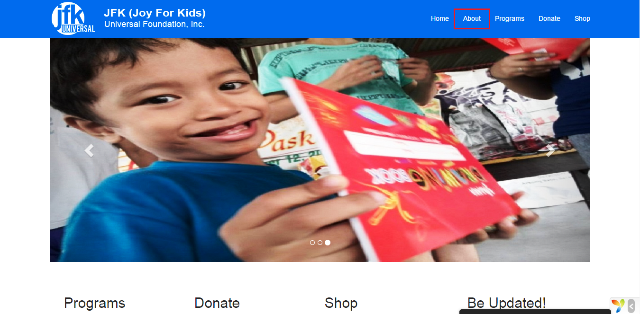

* When going to the about page, we can see the “ABOUT” tab in the header of site which has a red rectangle drawn to it.

2.2 ABOUT PAGE

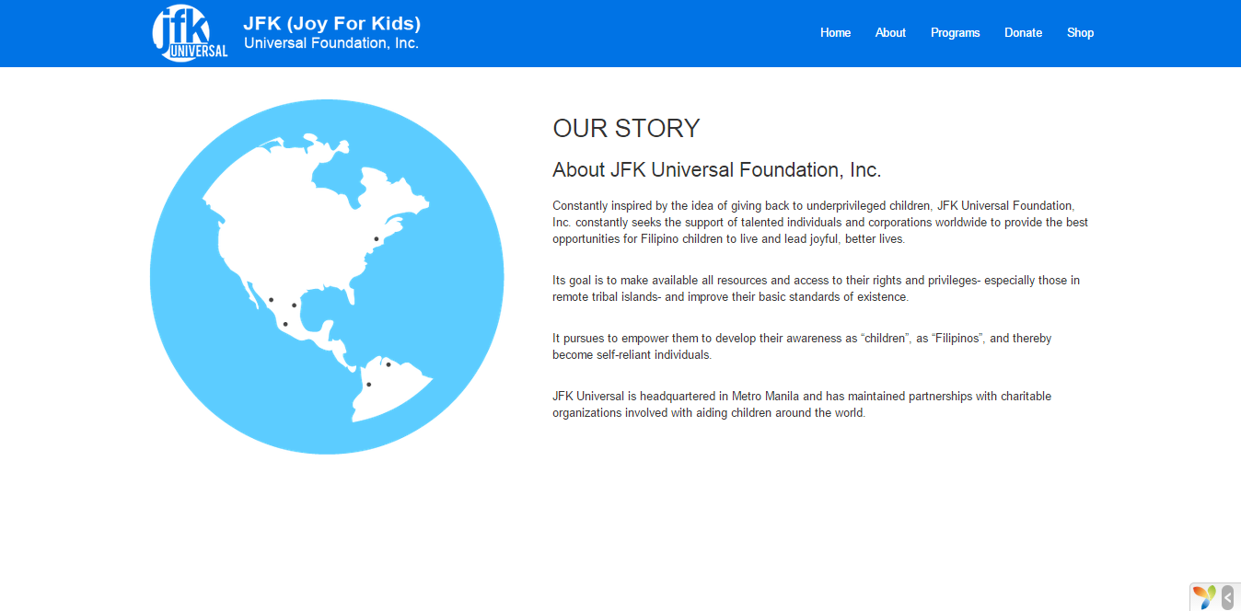

* In this screen shot, we can see the story of the company and how it was founded and what the purpose of in creating a foundation.

1. **PROGRAM PAGE**

3.1 Preview of Program Page

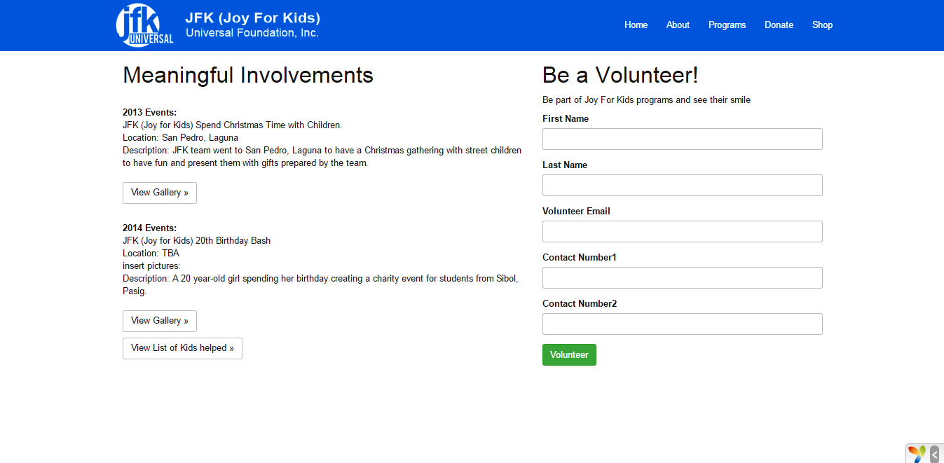

* In this page, we can see the past events created, and on the right side we can see that clients or customers can volunteer for events and help out in JFK (Joy for Kids).

3.2 Preview of Gallery Page

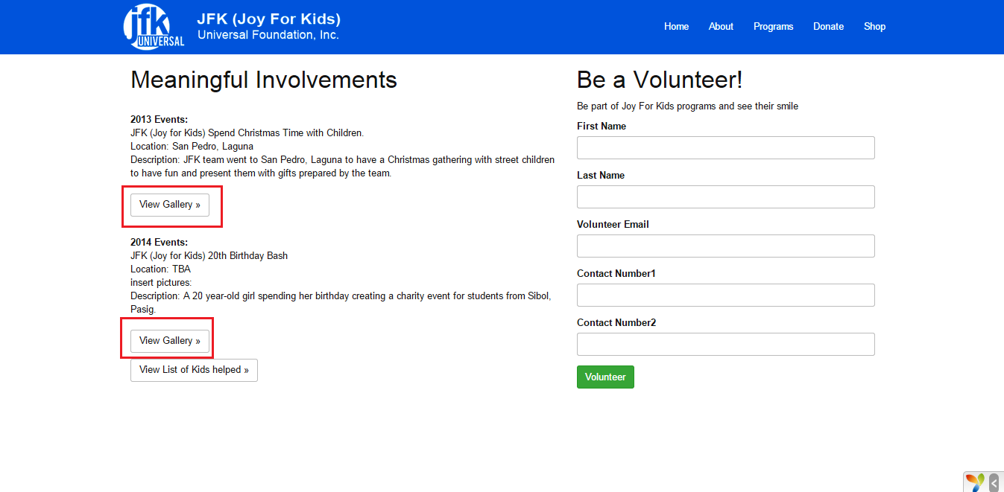

* In clicking on the “View Gallery”, it will redirect to a page were you can see pictures of the said event.

3.3 One of the Gallery Pages

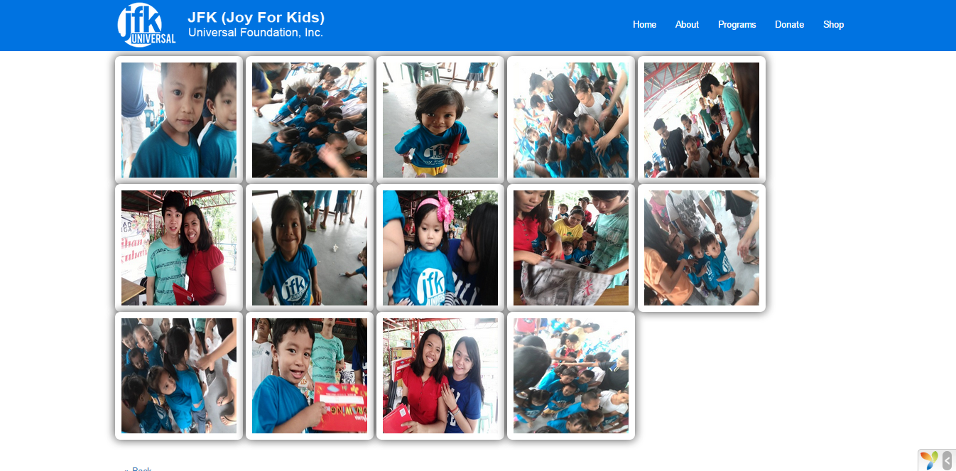

3.4 Example of an Enlarged Picture

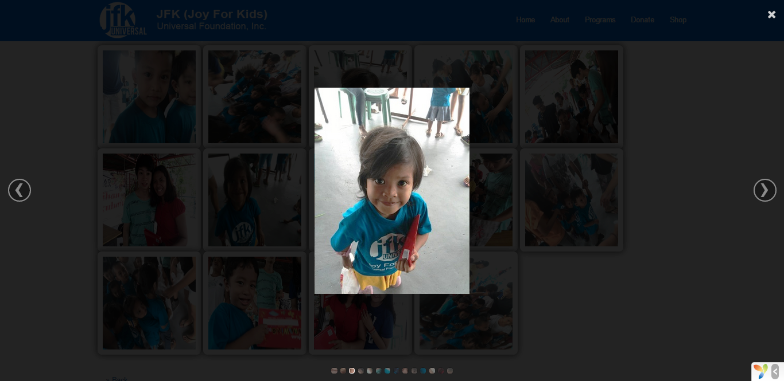

* As shown here, these are pictures from one of the events created by JFK (Joy for Kids). Clients and customers can hover and click one of the pictures and I will enlarge.